EPAM University Programs
DevOps external course
Module 4 DevOps Introduction

TASK 4.2

1. Set up Linux Virtual Machine in VirtualBox.
Done

2. Familiarize yourself with the commands and utilities listed in the presentation
(switching between virtual terminals (consoles); printenv; content of
/etc/profile and ~/.bash_profile, $echo $HISTFILE $HISTSIZE
$HISTFILESIZE, who, w, whoami, id).

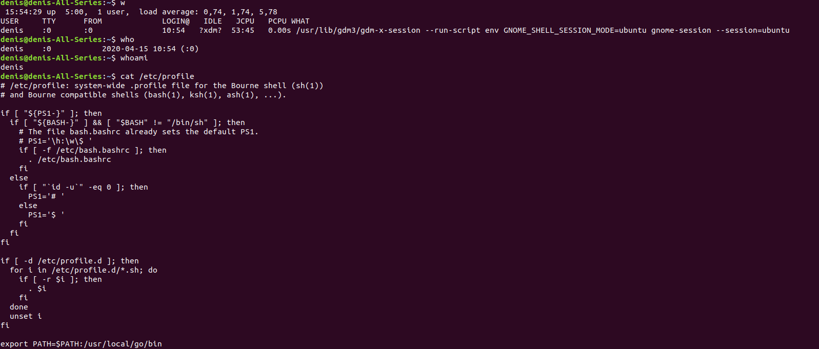

3. Familiarize yourself with the commands (uname, hostname, uptime,
shutdown, halt, reboot, init…).

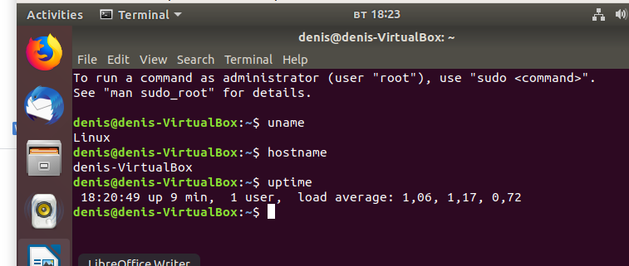

4. Familiarize yourself with the help commands (man, info, find, locate, whereis,
less|zless in /usr/share/doc).

